**Practical : 04**

**Aim :** Whether Analysis Application using Python and MapReduce

**Aim : Weather Analysis using MapReduce.**

**Step 1 : Open terminal > Add the weather.txt file and create mapper.py and reducer.py.**

**[cloudera@quickstart Desktop]$ mkdir weather**

**[cloudera@quickstart Desktop]$ cd weather**

**[cloudera@quickstart weather]$ touch weather.txt**

**[cloudera@quickstart weather]$ ls**

**weather.txt**

**[cloudera@quickstart weather]$ touch mapper.py**

**[cloudera@quickstart weather]$ touch reducer.py**

**Step 2 : Open mapper.py and write the code.**

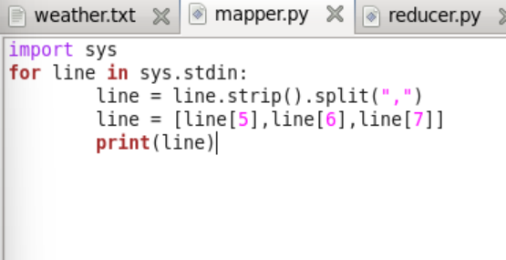

**Step 3 : Open reducer.py and write the code.**

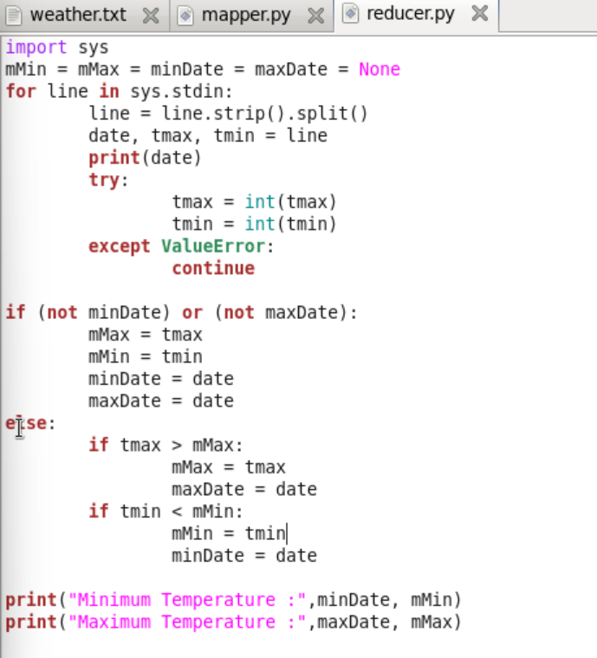

**Step 4 : Running the mapper function with weather.txt file to check the output.**

**[cloudera@quickstart weather]$ cat weather.txt | python mapper.py**

**Output:**

**20100101 -178 -311**

**20100102 -244 -322**

**20100103 -194 -289**

**20100104 -167 -200**

**20100105 -133 -167**

**20100106 -133 -172**

**20100107 -150 -278**

**20100108 -233 -328**

**20100109 -233 -322**

**20100110 -117 -244**

**20100111 -67 -128**

**20100112 -78 -122**

**20100113 -17 -89**

**20100114 39 -72**

**20100115 -67 -72**

**20100116 22 -50**

**20100117 33 -44**

**20100118 6 -172**

**20100119 -56 -183**

**20100120 -67 -139**

**20100121 -67 -94**

**20100122 -44 -67**

**20100123 -6 -44**

**20100124 0 -11**

**20100125 -11 -161**

**20100126 -161 -233**

**20100127 -167 -222**

**20100128 -167 -283**

**20100129 -189 -283**

**20100130 -156 -267**

**20100131 -150 -272**

**Step 5: The mapper function will put these values in the stream which will be used by the reducer function and give the output**

**[cloudera@quickstart weather]$ cat weather.txt | python mapper.py |python reducer.py**

**Output:**

**['20100101', '-178', '-311']**

**20100101**

**('Minimum Temperature:', '20100101', -311)**

**('Maximum Temperature:', '20100101', -178)**

**['20100102', '-244', '-322']**

**20100102**

**('Minimum Temperature:', '20100102', -322)**

**('Maximum Temperature:', '20100101', -178)**

**['20100103', '-194', '-289']**

**20100103**

**('Minimum Temperature:', '20100102', -322)**

**('Maximum Temperature:', '20100101', -178)**

**['20100104', '-167', '-200']**

**20100104**

**('Minimum Temperature:', '20100102', -322)**

**('Maximum Temperature:', '20100104', -167)**

**['20100105', '-133', '-167']**

**20100105**

**('Minimum Temperature:', '20100102', -322)**

**('Maximum Temperature:', '20100105', -133)**

**['20100106', '-133', '-172']**

**20100106**

**('Minimum Temperature:', '20100102', -322)**

**('Maximum Temperature:', '20100105', -133)**

**['20100107', '-150', '-278']**

**20100107**

**('Minimum Temperature:', '20100102', -322)**

**('Maximum Temperature:', '20100105', -133)**

**['20100108', '-233', '-328']**

**20100108**

**('Minimum Temperature:', '20100108', -328)**

**('Maximum Temperature:', '20100105', -133)**

**['20100109', '-233', '-322']**

**20100109**

**('Minimum Temperature:', '20100108', -328)**

**('Maximum Temperature:', '20100105', -133)**

**['20100110', '-117', '-244']**

**20100110**

**('Minimum Temperature:', '20100108', -328)**

**('Maximum Temperature:', '20100110', -117)**

**['20100111', '-67', '-128']**

**20100111**

**('Minimum Temperature:', '20100108', -328)**

**('Maximum Temperature:', '20100111', -67)**

**['20100112', '-78', '-122']**

**20100112**

**('Minimum Temperature:', '20100108', -328)**

**('Maximum Temperature:', '20100111', -67)**

**['20100113', '-17', '-89']**

**20100113**

**('Minimum Temperature:', '20100108', -328)**

**('Maximum Temperature:', '20100113', -17)**

**['20100114', '39', '-72']**

**20100114**

**('Minimum Temperature:', '20100108', -328)**

**('Maximum Temperature:', '20100114', 39)**

**['20100115', '-67', '-72']**

**20100115**

**('Minimum Temperature:', '20100108', -328)**

**('Maximum Temperature:', '20100114', 39)**

**['20100116', '22', '-50']**

**20100116**

**('Minimum Temperature:', '20100108', -328)**

**('Maximum Temperature:', '20100114', 39)**

**['20100117', '33', '-44']**

**20100117**

**('Minimum Temperature:', '20100108', -328)**

**('Maximum Temperature:', '20100114', 39)**

**['20100118', '6', '-172']**

**20100118**

**('Minimum Temperature:', '20100108', -328)**

**('Maximum Temperature:', '20100114', 39)**

**['20100119', '-56', '-183']**

**20100119**

**('Minimum Temperature:', '20100108', -328)**

**('Maximum Temperature:', '20100114', 39)**

**['20100120', '-67', '-139']**

**20100120**

**('Minimum Temperature:', '20100108', -328)**

**('Maximum Temperature:', '20100114', 39)**

**['20100121', '-67', '-94']**

**20100121**

**('Minimum Temperature:', '20100108', -328)**

**('Maximum Temperature:', '20100114', 39)**

**['20100122', '-44', '-67']**

**20100122**

**('Minimum Temperature:', '20100108', -328)**

**('Maximum Temperature:', '20100114', 39)**

**['20100123', '-6', '-44']**

**20100123**

**('Minimum Temperature:', '20100108', -328)**

**('Maximum Temperature:', '20100114', 39)**

**['20100124', '0', '-11']**

**20100124**

**('Minimum Temperature:', '20100108', -328)**

**('Maximum Temperature:', '20100114', 39)**

**['20100125', '-11', '-161']**

**20100125**

**('Minimum Temperature:', '20100108', -328)**

**('Maximum Temperature:', '20100114', 39)**

**['20100126', '-161', '-233']**

**20100126**

**('Minimum Temperature:', '20100108', -328)**

**('Maximum Temperature:', '20100114', 39)**

**['20100127', '-167', '-222']**

**20100127**

**('Minimum Temperature:', '20100108', -328)**

**('Maximum Temperature:', '20100114', 39)**

**['20100128', '-167', '-283']**

**20100128**

**('Minimum Temperature:', '20100108', -328)**

**('Maximum Temperature:', '20100114', 39)**

**['20100129', '-189', '-283']**

**20100129**

**('Minimum Temperature:', '20100108', -328)**

**('Maximum Temperature:', '20100114', 39)**

**['20100130', '-156', '-267']**

**20100130**

**('Minimum Temperature:', '20100108', -328)**

**('Maximum Temperature:', '20100114', 39)**

**['20100131', '-150', '-272']**

**20100131**

**('Minimum Temperature:', '20100108', -328)**

**('Maximum Temperature:', '20100114', 39)**

**[cloudera@quickstart weather]$ ^C**

**[cloudera@quickstart weather]$**